Ultimate Nerd Championship Weigh-in

Cast:

* Alec – Announcer
* Gordon - Commentator 1
* Audrey - Commentator 2
* Bricia – Drama Major
* Gabe, Lani – Film Major + Boom Mic Holder
* Misha – Humanities Major
* Lorn – Sociology Major
* Alyssa – Business Major
* Ryan – CS Major
* Tommy – Bio Major
* Mark – Engineering Major v
* Phero, Roy, Elijah - Background peeps
* Andria - Face-off photographer

Premise: UFC Weigh-in parody introducing “fighters” from different majors. All majors get roasted.

**Alec:**

Welcome to the official weigh-in for Ultimate Nerd Championship, the top study-off competition in the world! Today we weigh-in the top students in various divisions for this season’s UNC! Let’s start it off with the first two no-lifers facing off in the “I tried to make my hobby into my career” division, Gabriel Baltazar vs Bricia Marquez!

*Bricia tap dances onto stage like the extremely excited and expressive drama student she is. She’s wearing some crazy theater outfit for some random play or musical.*

**Audrey:**

Wow she looks so happy to be on stage it’s actually almost annoying.

**Gordon:**

Oh she definitely is. Drama students adopt a hit and run style, as Bricia will distract her opponents with random outbursts of songs from musicals and over the top impressions.

*Bricia steps on the scale and poses*

**Alec:**

Official nerd-weight: 110 cheap headshots!

*Bricia steps off to the side*

**Alec:**

And her opponent: Gabriel Baltazar!

*Gabe walks onstage with a camera in hand analyzing his footage and recording. Lani walks behind with a boom mic.*

**Audrey:**

He seems real confident in his ability to do nothing but sit around and watch movies for hours.

**Gordon:**

Gabe and his unimportant sound person are in fact so bad at filmmaking they pretentiously critique and judge what you watch to hide their insecurities.

*Gabe steps on the scale with Lani.*

**Alec:**

Official nerd-weight: 112 One-take Shots!

*Gabe steps off the scale and approaches Bricia for the photo op. They both flex and pose*

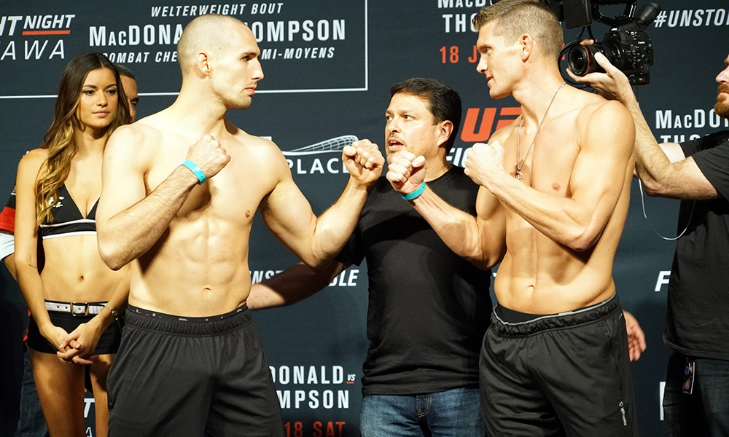

**Alec:**

Ready for an *entertaining* fight. Bricia Marquez and Gabriel Baltazar!

*Gabe and Bricia leave the stage.*

**Alec:**

The next pair of losers is for the “Just pretend to know what you’re talking about” division: Lorn Enriquez vs Misha Ponnuraju!

*Misha walks on stage flexing her classic novel dumbbells*

**Gordon:**

Humanities majors like Misha have mastered the ancient art of “Bull-shido”. They can turn “The Very Hungry Caterpillar” into a 12 page paper on Communism.

**Audrey:**

I really hope she doesn’t ask me to read her blog

*Misha steps on the scale and poses*

**Alec:**

Official nerd-weight: 120 re-reads of *The Fault in Our Stars!*

*Misha steps off to the side*

**Alec:**

And her opponent: Lorn Enriquez!

*Lorn walks on stage in hipster clothing with protest signs and a loudspeaker to protest about random shit.*

**Gordon:**

Sociology majors like Lorn have extreme endurance from protesting literally everything and suffering existential crises every day.

**Audrey:**

So instead of having a social life, they study it! Such commitment!

*Lorn steps on the scale and flips everybody off*

**Alec:**

Official nerd-weight: 123 Highly opinionated Facebook posts!

*Lorn approaches Misha for the photo-op. They both flex and pose*

**Alec:**

Let’s hope they make the 1600 round count minimum. Misha Ponnuraju and Lorn Enriquez!

*Lorn and Misha leave the stage.*

**Alec:**

Next we move on to the “I’m clearly just a sellout” division: Alyssa Liu vs Ryan Apolinar!

*Ryan walks on stage*

**Gordon:**

Ryan believes he’ll be richer than you once he drops out and finishes his ride-share food delivery social network music dating app called “Ubmateinstaspotinder”

**Audrey:**

Just because you can MAKE a dating app, doesn’t mean you can land any right swipes.

*Ryan steps on the scale and poses*

**Alec:**

Official nerd-weight: 165 Failed Technical Interviews!

*Ryan steps off to the side*

**Alec:**

Now for his opponent: Alyssa Liu!

*Alyssa comes on stage in formal business attire, looking prim and proper like the business student she is…OR looking like a frat dude with a short sleeve pastel shirt, short khakis, and sperry’s to nail that business frat bro vibe.*

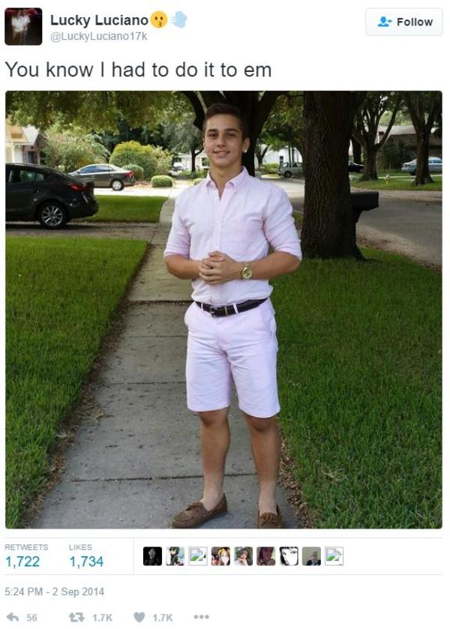

**Gordon:**

Alyssa “knows she had to do it to em” is definitely richer than you with her hard earned, parent-given money.

**Audrey:**

You can’t buy happiness, but you CAN buy alcohol.

*Alyssa steps onto the scale and poses*

**Alec:**

Official nerd-weight: 163 bottles of Jaeger!

*Alyssa and Ryan pose and flex for the photo-op*

**Alec:**

Truly a battle of who got luckier at birth. Alyssa Liu and Ryan Apolinar!

*Alyssa and Ryan leave the stage*

**Alec:**

Last up for our main event in the “I just want to sleep” division: Reigning virgin champion Mark Calabio vs Challenger Tommy Rocca!

*Tommy walks on stage shirtless in a lab coat and chem goggles.*

**Gordon:**

Biology students use their strong memorization skills to remember the names of those who fall and become PSB and Public Health majors.

**Audrey:**There must be so many of them because they can’t do anything else in STEM.

*Tommy steps on the scale and poses*

**Alec:**

Official nerd-weight: 195 O-chem labs!

*Tommy steps to the side*

**Alec:**

And his opponent: Reigning virgin: Mark Calabio!

*Mark walks on stage crying and wearing super nerdy clothes and carries bags of huge books and calculators.*

**Audrey:**Oof, Engineers have it tough. They would cry themselves to sleep if they could get any.

**Gordon:**

Using their strong problem solving skills and pages of formulas, Engineers like Mark can figure out if 35% is a passing physics grade or their chances of getting a date this month.

*Mark steps on the scale and cries*

**Alec:**

Official nerd-weight: 197 Right-hand rules!

*Mark approaches Tommy for the photo-op. They flex and pose.*

**Alec:**

Will it all be worth it post-grad? Probably not, but find out tomorrow anyways at the most underwhelming competition of the year: The Ultimate Nerd Championship!